**INDORE INSTITUTE OF LAW**

(AFFILIATED TO D.A.V.V & B.C.I)

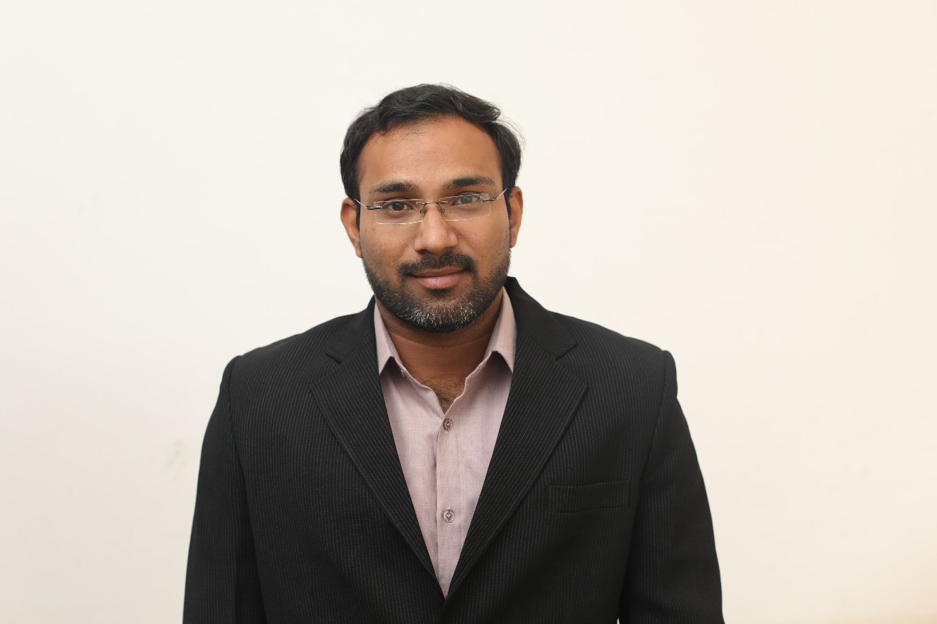

**ABOUT THE FACAULTY**

**Mr. VIVEK WILSON**

I started my professional career in 2016 as a teaching intern at the RNB global University, Rajasthan. Due to the research capabilities, I have been selected as a clerk under Hon’ble judge of high court and Supreme Court. My time at the Supreme Court and high court happened when the institution of research clerks was viewed with growing perspective of the legal field and hence making a space for the position was an uphill task. Even so the learning on the judicial culture and psychology are irreplaceable. After the Court experience, I have worked at the various government organisations, where I had the hands on opportunity to learn to research, write, and edit in association with renowned legal luminaries.

In 2016 may I have joined IIL as its first full time Assistant professor. Since I had pre-dominant experience in research I had the enthusiasm of a fresh recruit towards my teaching, which coupled with the authority, and allowed experimentation. My enthusiasm was seen by the fact that as a multiple discipline institute which has easier protocols for floating courses, amending curriculums and experimenting with evaluation. I teach like a researcher and my courses do not impart existing information but dwell on questions that need further investigation. Since our students stay with us over extended periods of time, I have enjoyed the opportunity to build learning together relationships with them.

**DESIGNATION AND QUALIFICATION-:**

**Assistant professor-: LL.M (International Trade law) (NALSAR), B.A.LL.B (Hons.) (RMLNLU)**

**RESEARCH WORK-:**

1. ***State Law Commission Lucknow November 2009-:*** Doctrinal work on the topic of JAIL REFORMS.
2. ***State Human Rights Commission December 2009-:*** Doctrinal work on the topic of INCREASING CORRUPTION AND EXCLUDING HUMAN RIGHTS VIOLATION.
3. ***Law commission of India december2011-:*** Doctrinal work on INTER COUNTRY ADOPTION.
4. ***Delhi Legal Service Authority New Delhi December 2010*** -: Non-doctrinal work with certain NGO’s.
5. **DISSERTATION** -: Recognition and enforcement of foreign arbitral Awards-: (A critical Analysis of the Indian Approach)

**BOOKS AND ARTICLES PUBLISHED-:**

1. With Varsha Upadhaya, “***Ecology and air as a part of Article 21***”, 4(1), **National Law journal the Legal Voice of India**. (2015-16) 22778454
2. With Varsha Upadhaya, “***Digital Rights in Management***”, **National Law journal Udgayam Vigyati**. (2015-16) 2455-2488
3. With Kusum Joshi, “***JESSICA LENAHAN (GONZALES) V. UNITED STATES* AND THE INTERAMERICAN COMMISSION’S APPROACH TO EQUALITY”**, **National Law journal Udgayam Vigyati**. (2015-16) 2455-2488

**Conferences Attended-:**

1. *Presented Paper at National Law University Delhi on current* ***SOVEREIGNITY AND FUNCTIONAL AIRSPACE.***
2. *Presented Paper at Indian Society of International Law New Delhi on* ***biodiversity and Traditional Knowledge.***
3. *Presented Paper at Dr. Ram Manohar Lohiya National Law University Lucknow On* ***Cyber Law****.*
4. *Presented Paper at International Conference on* ***Environmental Issues in Advanced & Emerging Economies Canada & India*** *(Ahamadabad)*
5. *Presented Paper at Baba Saheb Ambedkar University Lucknow on, the Topic* ***Caste System as an A Violation of Human Rights.***
6. *Presented Paper at National university of judicial sciences west Bengal on, The Topic* ***role of good governance for poverty alienation in urban and rural India: a critical analysis****.*
7. *Presented Paper at Dr. Ram Manohar Lohiya National Law University Lucknow on* ***The media, crime prevention and urban safety****.*

**ADDITIONAL COURSE-:**

1. *Summer Course on* ***INTERNATIONAL LAW****at Indian Society of International Law New Delhi.*
2. *Course on* ***RESTORATIVE JUSTICE*** *at Dr. RMLNLU under Professor Martin.*
3. *Seminar course on* ***child law****.*
4. *Seminar course on* ***law and morality****.*
5. *Seminar course on* ***International Environmental Law****.*
6. *Seminar course on* ***Law Science and Technology****.*
7. *Seminar course on* ***Socio-Economic Crimes.***
8. *Seminar course on* ***Diversity Management and minority rights in India****.*

***COURSE TAKEN-:***

*Constitutional law, Law of torts, evidence law, jurisprudence, transfer of property law, law of contract.*

***CONTACTS****-:*

*E-mail-:* [*vivek158wilson@gmail.com*](mailto:vivek158wilson@gmail.com)*, contact-: 9616182869.*