Indore Institute of Law
(Affiliated to D.A.V.V & B.C.I)
About the Faculty: Dr. Vivek Singh
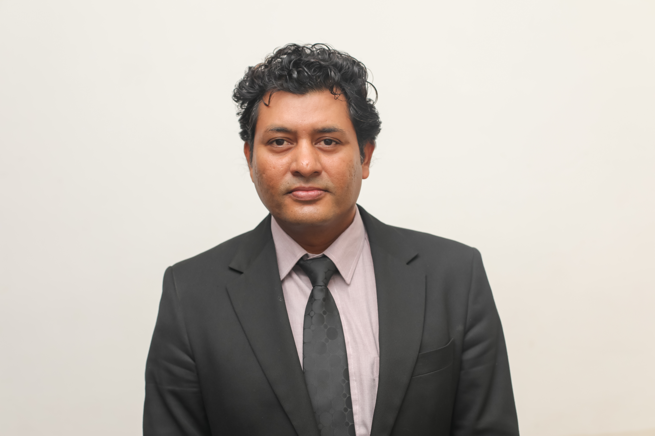
- Dr. Vivek Singh is working as Assistant Professor of History in Indore Institute of Law, Indore, M.P. India. He has over 11 years of rich experiences in the field of academics, Management, Media, research and Archaeology. Previously, he has worked as Assistant Professor as a Guest Faculty at Government Post Graduate College, Neemuch (M.P), India, for academic year 2011-12. He taught as a Guest Faculty at Ujjain University affiliated, Government Post Graduate College, Shajapur (M.P), India, for academic year 2003-04 to teach PG classes (M.A level). He has also worked in Corporate world as General Manager of Choki Dhani Resort, Indore ( Ethnic resort) & Shell City resort . He has done Ph.D. in History from Devi Ahilya University Indore (M.P), India, awarded in March 2006. & M.Phil in History from school of Advanced Liberal Studies, Devi Ahilya University Indore.(M.P), India, along with Diploma in Hotel management. He has also attended various Seminar & Conferences at National & International Levels. He is also a graduate member of All India Management Association.
Designation
Dr. Vivek Singh is working as Assistant Professor ( History) in Indore Institute of Law,
Indore.
Qualification
- Ph.D. in History from Devi Ahilya University Indore (M.P), India, awarded in March 2006.
- M.Phil in History from school of Advanced Liberal Studies, Devi Ahilya University Indore.(M.P), India.
- Master of Arts in History (M.A) from Devi Ahilya University Indore, India.
- Bachelors of Arts (B.A) from Devi Ahilya University Indore.
- Diploma in Electronic Media.
- Diploma in Hotel Management from Institute of Management Studies, D.A.V.V, Indore

Workshop/FDP/Short Term Course
- Attended the National Workshop on Numismatics and Sigillography, D.A.V.V, Indore.
- Member in the Archaeological field School at Bukovac, Serbia, Europe, in 2006.
- Invited as guest lecturer at Petnica Science Center, Valijevo, Serbia, Europe, in 2006.
- Member of electronic Media team, National Geographic Society in Russia in 2006
- Worked as a Researcher for Arc Films, Noida, India.
- Participated in National Conference organized by National Museum.
- More than 10 Research Publications in Peer reviewed national and International Journals.

Courses Taken/ Subject Taught
- Ancient History of India & World
- Medieval History of India & World
- Modern History of India & World
- Archaeology
- Numismatics

Email & Contact-: Contact: +919826010052Email: vivek.indigo@gmail.com

