**Indore Institute of Law**

(Affiliated to D.A.V.V & B.C.I)

**About the Faculty: Dr.Varsha Upadhyay**

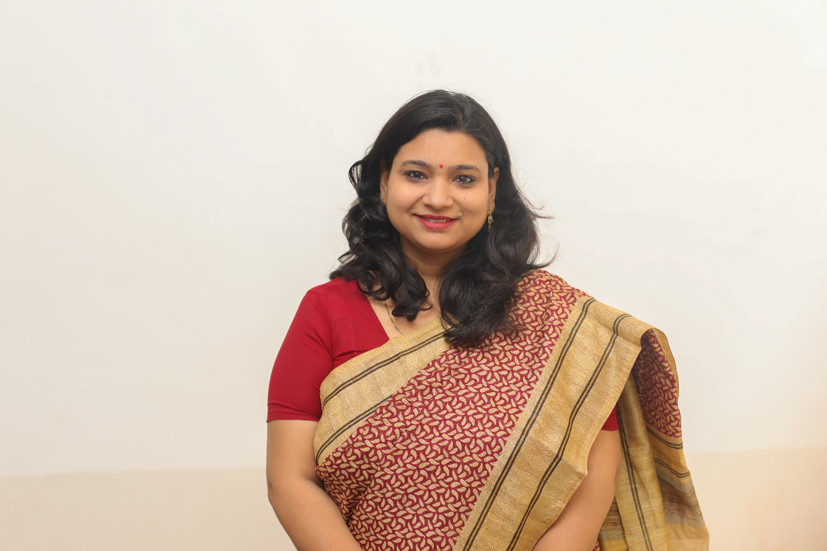

**ABOUT THE FACULTY**

I joined Indore Institute of Law in September 2015. Before joining IIL I was the instructor in Pre examination training Centre ( bhoj mukt vishwavidhyalaya Indore) and having expertise in the subject Political Science (2004-2015). I was also in the selection committee member of the mock interview panel in the said institute for grooming the candidates for civil services. I was Instructor for Civil Services in Dr. Baba Saheb Ambedkar University of Social Sciences, Mhow for Political Science. I have 15 years of Experience in the field of Academics. I have been holding the post of Academic Coordinator and batch coordinator also.

**DESIGNATION AND QUALIFICATIONS**

Asst Professor (working as Academic Coordinator April 2016 till date)

Ph.D (International Relations), NET Qualified (2000), M.Phil (Political Science)

M.A (Political Science, B.A (Arts) (Rajasthan University)

**RESEARCH WORK**

**Ph.D** Awarded in 2006 in the faculty of Political Science on “Bhartiya Videsh Niti: Narsimha Rao ke kaal mein”

**M.Phil** in the faculty of Political Science on “Bhartiya Videsh Niti: Gutnirpekshta ke paripekshya mein”

**8 candidates have been registered** in MPhil Dissertations to the students of **School of Social Sciences DAVV**, Indore for Political Science.

**Articles:**

* **“A Summary on CSR when social issues become strategic”** International Journal of Engineering and Applied Vol. 4, Issue 2 ISSN(o): 2394-3661 **Thomson Reuters Indexed**
* **“An impression of CSR and its growing implication in India 2016” Global journal of Commerce & Management Perspective** Vol 6 ,Issue 2**,** bearing ISSN 2319-7285 **Scopus Indexed**
* **Ecology & Air Pollution as a part of Article 21,**National Journal The Legal Voice of India Vol 4 (2015) ISSN No 2277-8454
* **“Digital Rights in Management”** in National Journal Udgam Vigyati – The Origin of Knowledge bearing ISSN 2455-2488

**Courses Taken (Subject Taught):** Political Science, Pub. Admin., International Relations, Interpersonal Skills