**INDORE INSTITUTE OF LAW**

(AFFILIATED TO D.A.V.V & B.C.I)

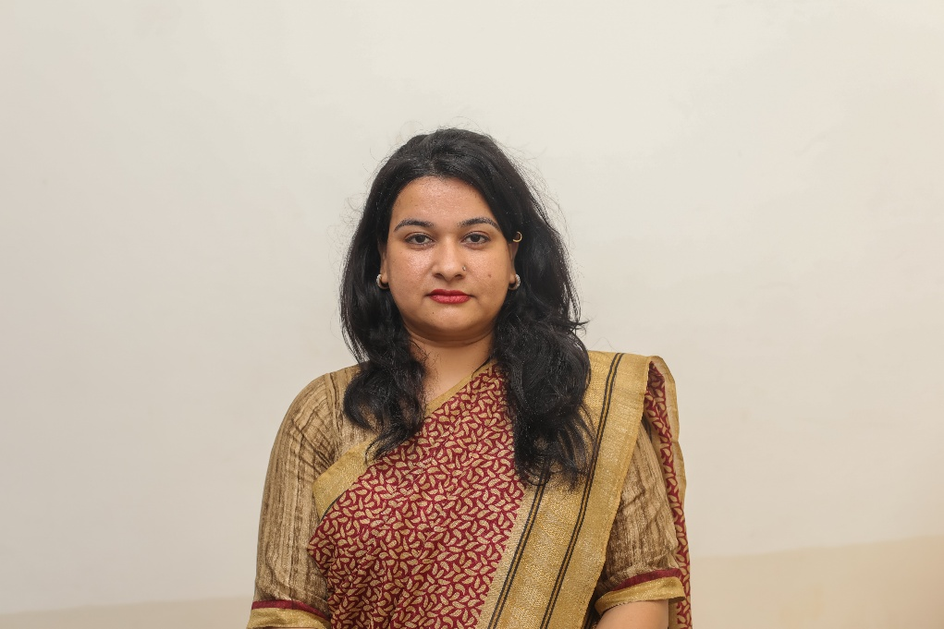

**ABOUT THE FACAULTY**

**Dr. SAMEERA KHAN**

**She has been graciously interested towards Hindi sahaitya from her secondary education. While she was pursing M.phil degree she has started teaching in the field of Hindi in graduation classes in Jagdalaya College (DAVV) for six months. After this she moved towards Radiant College for teaching in Hindi for 1 year, and she has also taught in Arena animation institute for 1 year. After this she has joined IIL (DAVV) as Assistant Professor and presently she is teaching legal Hindi to the student of law, she is a batch coordinator and coordinator to NSS. In IIL she has been coordinating the sports club to BBA Exclusive.**

**DESIGNATION AND QUALIFICATION-:**

**Assistant professor-: Ph.D (Hindi Literature), M.phil (Hindi Literature), M.A.(Hindi Literature), B.A.**

**RESEARCH WORK-:**

**Ph.D thesis Topic-:** *SAMAKAALEEN HINDI KAHAANIYO MEIN VARISHT NAGRIKYO KI VYATH KATHA 1980 SE* ADHAYAN AVDHI.

**M.Phil-:** *Aik Stri Ki Aatm Hathy Upanyas Ki Tatwik Samiksh.*

**BOOKS PUBLISHED-:**

***HINDI BHASHA***

***COURSE TAKEN-:*** *Hindi (sahitya), Hindi language, Udyamita ka Vikas, legal hindi.*

***CONTACTS****-:*

*E-mail-:* [*dr.sameera7283@gmail.com*](mailto:dr.sameera7283@gmail.com)*, contact-: 9893498202.*