**Indore Institute of Law**

(Affiliated to D.A.V.V & B.C.I)

**About the Faculty: Miss Seemasmiti Pattjoshi**

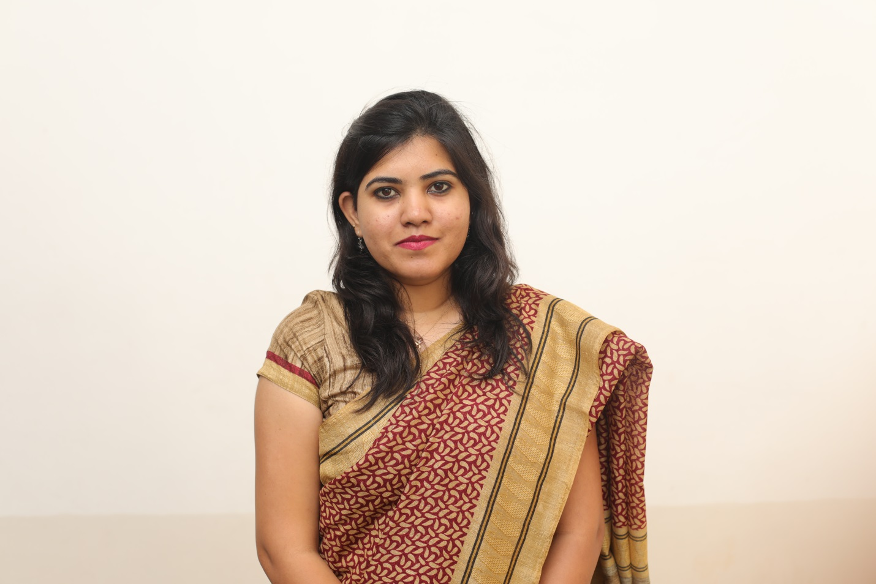

**Ms Seemasmiti Pattjoshi** is working as Assistant Professor in Indore Institute of Law, Indore M.P. India. She has 1 year 6 months of rich experiences in the field of academics with Indore Institute of Law 2 years of experience as an Advocate. Previously, she has worked as an Advocate in District Court and High Court of. She is pursuing his Ph.D. from KIIT School of Law, Bhubaneswar in the specialization on Corporate Law and International Commercial Arbitration. Her areas of interest are contract, corporate law competition law, banking law, ADR etc. She has done her graduate from MS Ramaiah College of Law, Bangalore, Karnataka and Postgraduate in Law from National Law University Odisha, Cuttack. She is also registered Advocate. She is an energetic and enthusiastic person who enjoys a challenge and achieving personal goals. She has not only work experience with academics but also had experience of client counselling, drafting and court attending in High Court. She has also attended various Seminar & Conferences at National & International Levels.

**Designation**

* Ms Seemasmiti Pattjoshi is working as Assistant Professor in Indore Institute of Law, Indore (M.P.)

**Qualification**

1. Pursuing Ph.D. in KIIT School of Law, Bhubaneswar.
2. LL.M. From National Law University Odisha, Cuttack.
3. B.A.LL.B. from M S Ramaiah College of Law, Bangalore.
4. Diploma Course on IPR and Cyber law From Indian Institute of Law.

**Research Work**

**Pursuing Ph.D. from KIIT School of Law**

* Research paper on ***Determining theparties- True choice of seat of the Arbitration and Lex Arbitri*** at IJCRT, ISSN No: 2320-2882
* Research paper on **Krishna Water dispute- Acritical analysis** at UDGAM VIGYATI, ISSN No: 2455-2488 Vol no. 6
* Research paper on Freedom of Commercial Speech and Expression Under Indian Constitution, LVI,ISSN No. 2277-8454 Vol. 5
* Pursuing Ph.D. in Business law and Arbitration.
* Research has done in Commercial and Corporate law under NLUO, Cuttack in the topic “Companies liability for Commercial Speech”.
* Research topic on Commercial Bank vs. Merchant Bank- a Critical analysis.
* Research topic on Role of Courts u/s 8 of Arbitration & Conciliation Act 1996.
* Research topic on Freedom of Commercial Speech and expression under Indian Constitution published on Legal Voice of India.

**Workshop/Seminars/ Moot courts/Short Term Cours**

1. Workshop attended on **Research & Thesis Writing at KIIT School of Law**, Bhubaneswar during 11th -15th October 2017.
2. Workshop attended on **Research Methodology at KIIT School of Law**, Bhubaneswar during 27th Jan 2017 to 2nd Feb 2017.
3. **International Conference on Rethinking Legal Education in India** at Karnataka State Law University, Karnataka on 30th and 31th Oct 2012.
4. Attended **1st World Law Dialogue** organized by Alexis Centre for study and Research in Law at Karnataka University, Karnataka on 29th- 31th Aug 2013.
5. **National Conference on Intellectual Property Rights** at KIIT School of Law, Bhubaneswar on 12th -14th Sep 2013.
6. Attended **1st Magna Carta National Legal Seminar** at M S Ramaiah School of Law, Bangalore on 17th Nov 2012.
7. **Moot Court participated at Saveetha School of Law**, Chennai held during 19th- 21th Apr 2012.
8. Participated **5th GNLU International Moot Court Competition** organized by Gujarat National School of Law held on 6th -10th Feb 2013.
9. Diploma course on Cyber law at Indian Institute of Law.
10. Diploma course on Intellectual Property Rights at Indian Institute of Law.

**Courses Taken/ Subject Taught**

* Banking Law.
* Constitutional Law
* Admin Law
* Contract.
* Alternative Dispute Resolution.
* Environmental Law
* Transfer of Property law

**Personal Details**

* Father’s Name Shri Sisir Ku. Pattjoshi
* Date of Birth 03rd July
* Marital Status Unmarried
* Nationality Indian
* Hobbies Reading books and Tracking