**INDORE INSTITUTE OF LAW**

(AFFILIATED TO D.A.V.V & B.C.I)

**ABOUT THE FACULTY:** SACHIN VERMA

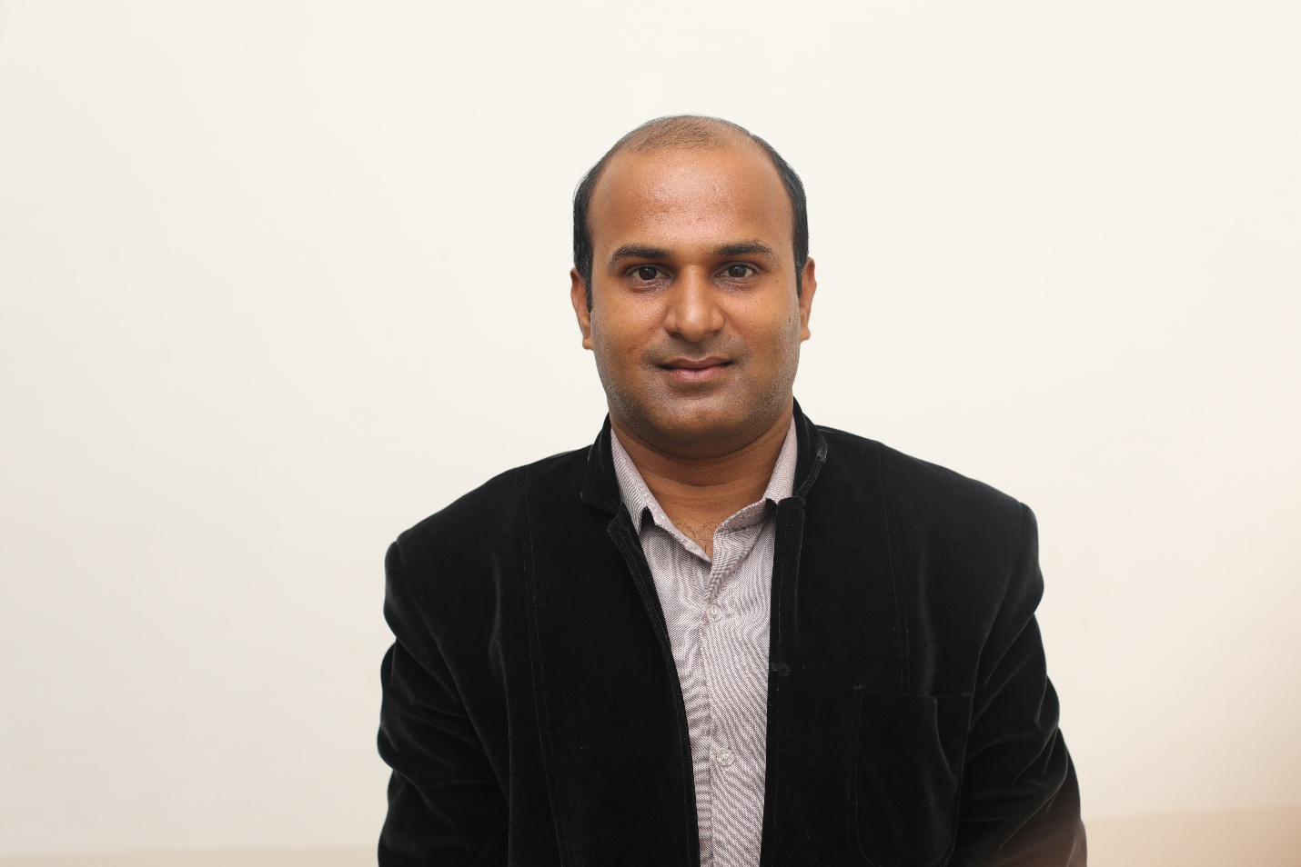

About the Faculty

Mr. Sachin Verma, Asst Professor in Indore Institue of law. He is an academician with a passion for teaching and learning. In his teaching experience of more than Five years, He has taught variety of subjects at UG and PG level like Company law, Jurisprudence, Hindu law, Law of torts, Contract law, Banking laws, Law and Social Transformation in India.

I Completed My LL.M (Business law) and LL.B from Maharaja Sayajirao University of Baroda and B.B.A from Barkatullah University Bhopal.

SEMINAR AND CONFERENCES:

* Organized National Seminar on “Studying Law through Constitutional Ideas and the Emerging Roles of Lawyers”
* Attended National Workshop on “Conceptual and Methodological framework of Social and legal Research” at Govt. New Law College, Indore on 20th March 2016.
* Participated in the National Symposium on “Whither Indian Judiciary” on 21st June 2016. Keynote Speaker was Hon’ble Justice Markandey katju.
* Attended International Workshop on “Legal Writing and Contract Drafting Training” by British Legal Centre 4th & 5th May 2015.
* Attended International Workshop on Cyber law & Security on 17th Dec 2015.
* Attended One Day Workshop on “Intellectual Property: Law and Management: in association with Enhelion Knowledge Ventures Pvt Ltd on 4th June 2015.
* Attended Workshop on Faculty Development Programme conducted by Indore Institute of law at Indore on 4th April 2015.
* Attended one day workshop on ‘Faculty Development Programme’ conducted by Indore Institute of Law at Indore on 19th April, 2014.
* Participated in National Seminar on “Challenges of Human Right in 21st Century” at School of Law, Devi Ahilya University, Indore, Sept 12-13, 2013.
* Participated in National Symposium on “Criminal Trial & Investigation System In India” at Indore Institute of Law, Indore Aug 17, 2013.
* Participated in National Seminar on “Position of Indian Language in the field of Law and Justice” at School of Law, Devi Ahilya University, Indore, Feb 23, 2013.
* Participated in National Symposium on “The Constitution and the Courts” in Indore, Dec 21, 2012.
* Participated in “An International seminar on South Korea, Italy and Spain- Legal and Judicial Issues and Solutions” jointly Associations with Gujarat National Law University, Gandhinagar and Sardar Patel University, Anand, at Law College, Anand Gujarat, India , 2011.
* Participated in “National Law Conference on “Rule of Law” at Baba Farid Law College, Faridkot, Punjab. Sept 29-30, 2006.

RESEARCH PAPER PUBLICATIONS:

* Publication in “The Legal Voice of India” on the topic of ‘Legalization of Prostitution in India’. ISSN NO. 2277-8454.
* Publication in “Altius Shodh Journal of Management & Commerce” on the topic of ‘A Study on Laws relating to Industrial designs’. ISSN No.2348-8891
* A Review Paper of “Interpersonal Relationship at Workplace” in “Udgam Vigyati”-The Origin of Knowledge ISSN No.2455-2488

**ASST. EXAM CONTROLLER FOR UNIVERSITY EXAMS**

**NSS PROGRAMME OFFICER INDORE INSTITUTE OF LAW**

NATIONAL SERVICE SCHEME (NSS):

* Organized Seven days College Camp at Village Tillore ,District Indore from 29/2/2016 to 6/3/2016
* Three college NSS Camp
* One University Level NSS camp
* ‘B’ Certificate of National Service Scheme

BATCH CORDINATOR OF LLM

DISSERTATION GUIDED FOR LLM:

Guided 10 Student for their Dissertation.