**INDORE INSTITUTE OF LAW**

(AFFILIATED TO D.A.V.V & B.C.I)

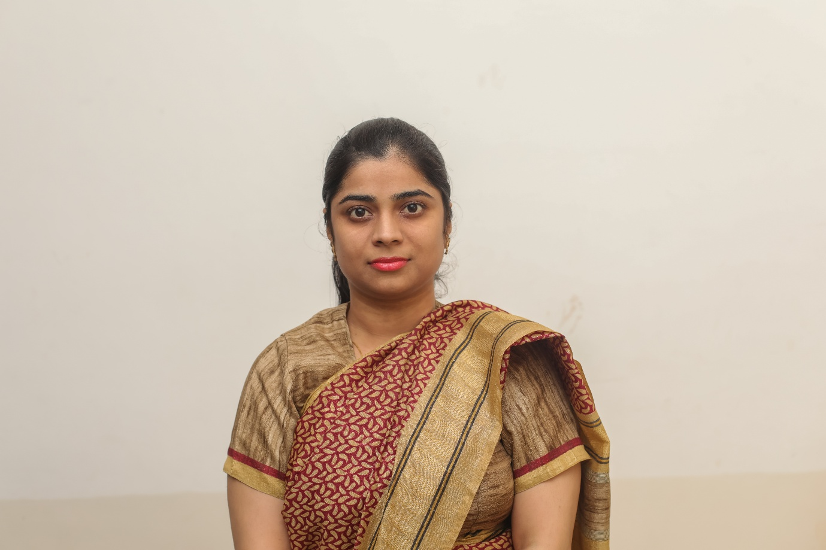

**ABOUT THE FACAULTY**

**Mrs. Rupali Rathore**

I have been teaching at Prestige Institute of Management and research (Department Of law) since 2015, in UG and PG department of law (PIMR), presently I am teaching in Indore Institute of law. I practised at the Madhya Pradesh bar for 2 years. I was fascinated by the inspiration of advocacy based on the research and creating a young generation of lawyers who would be proverbial with the best traditions of advocacy. I was born and have completed my education in Indore. I seek work-life balance to keep me going and like to be engaged in a variety of activities connected with law. I was the Batch coordinator for the 3 year and 5 year B.A./B.B.A.LL.B Programme.

**DESIGNATION AND QUALIFICATION-:**

**Assistant professor-:**

* **Ph.d (pursuing)**
* LL.M (Business Law)  **School of Law D.A.V.V, Indore (M.P)**
* LL.B. (HONS) **Shri Vaishnav Institute of Law** **D.A.V.V Indore (M.P)**
* M.B.A (HR) **Punjab Technical University**
* B.COM (FOREIGN TRADE) **M.B Khalsa College Indore (M.P)**

**RESEARCH WORK-:**

1. **DISSERTATION** -: **Critical analysis of control on mutual funds by SEBI**.
2. **PhD**  Research Scholar  (Law) Enrollment Year 2015 **Course Work** Completed **RDC** Conducted **Topic**–Surrogacy in India: Violation of Human Rights of Women A Study with Special Reference to State of Madhya Pradesh **Jagran Lake City University, Bhopal (M.P)**

**BOOKS AND ARTICLES PUBLISHED-:**

**BOOKS**

Book published “Cross Border Terrorism in India” , ISBN 978-93-8357-538-1

**ARTICLES**

* Research Paper published in Research Paper published in Journal on Contemporary Issues Of Law, ISSN 2455-4782 Volume 2 Issue 9 (Oct, 2016) Title-“Honor Killing: An Evil of Society with reference to Khap Panchayat
* Research Paper published in Journal on Contemporary Issues Of Law, ISSN 2455-4782 Volume 2 Issue 6 (July, 2016) Title- “Surrogacy: A Baby Factory”
* Research Paper published in Journal on Contemporary Issues Of Law, ISSN 2455-4782 Volume 2 Issue 5 (June, 2016) Title- “Immoral Trafficking of Girls: A Critical Analysis”
* Research Paper published in Journal on Contemporary Issues of Law, ISSN 2455-4782 Volume 2 Issue 4 (May, 2016) Title- “Sexual Harassment at Work Place of Both the Sex”
* Participated And Presented Paper In International Conference On Women Studies & Social Sciences 2016 At Carmel College, Nuvem, Goa (March 03-05, 2016) Title-“Women Want To Be Safe Not to Be Raped”
* Abstract Published In International Multidisciplinary Research Foundation, IMRF (ISBN 978-93-84124-67-0).International Conference On Women Studies & Social Sciences 2016,International Multidisciplinary Research Foundation, IMRF (ISBN 978-93-84124-67-0)

**Paper Presented-:**

1. Participated in regional conference on Juvenile Justice and capacity Building to ensure Proper implementation of law relating to child organized by Madhya Pradesh Judicial academy, Madhya Pradesh state Legal Services Authority and Unicef, MP on 26-27 November at brilliant Convention centre Indore.
2. Participated in thirty six National Case writing workshop organized by Prestige Institute of management in collaboration with association of Indian Management on November 28 to 30, 2016.
3. Participated in one week Faculty Development program organized by Prestige Institute of management, Department of law on July 11 to 15, 2016.
4. Participated in one day Faculty Development program organized by Prestige Institute of management on May 4, 2016.
5. Participated And Presented Paper In International Conference On Women Studies & Social Sciences 2016 At Carmel College, Nuvem, Goa (March 03-05, 2016) Title-“Women Want To Be Safe Not to Be Raped”
6. Participated in International Conference On Life Skills Education on 26-27 February 2016 organized by Jagran Lake City University, Bhopal (M.P)
7. Participated in National Workshop on Choice Based Credit System and Its Implementation Outcomes Sponsored by NAAC organized by Prestige Institute of Management and Research Indore (M.P) ON 7-8-9 January 2016.
8. International Conference On " Human Rights : Contemporary Issues And Challenges On 2-3 October 2015 Organized By School Of Law, Jagran Lake City University, Bhopal (M.P).
9. International Conference On "Gandhi Disarmament And Development" On 4-5-6 October 2013 Organized By Universal Peace And Social Development Society Indore.
10. National Conference On "Human Rights Challenges" On 12-13 September 2013 Organized By School Of Law, D.A.V.V Indore (M.P).

***COURSE TAKEN-:***

*Family law, Evidence law, Indian penal code, Law of contract, penology and vicitimology, law on education, Intellectual Property law, International competition law*

***CONTACTS****-:*

*E-mail-:* [*rupalirathore05@gmail.com*](mailto:rupalirathore05@gmail.com)*, contact-: 9893068466.*