**INDORE INSTITUTE OF LAW**

**(AFFLIATED TO DAVV)**

**ABOU THE FACULTY**

**dr.reva mishra**

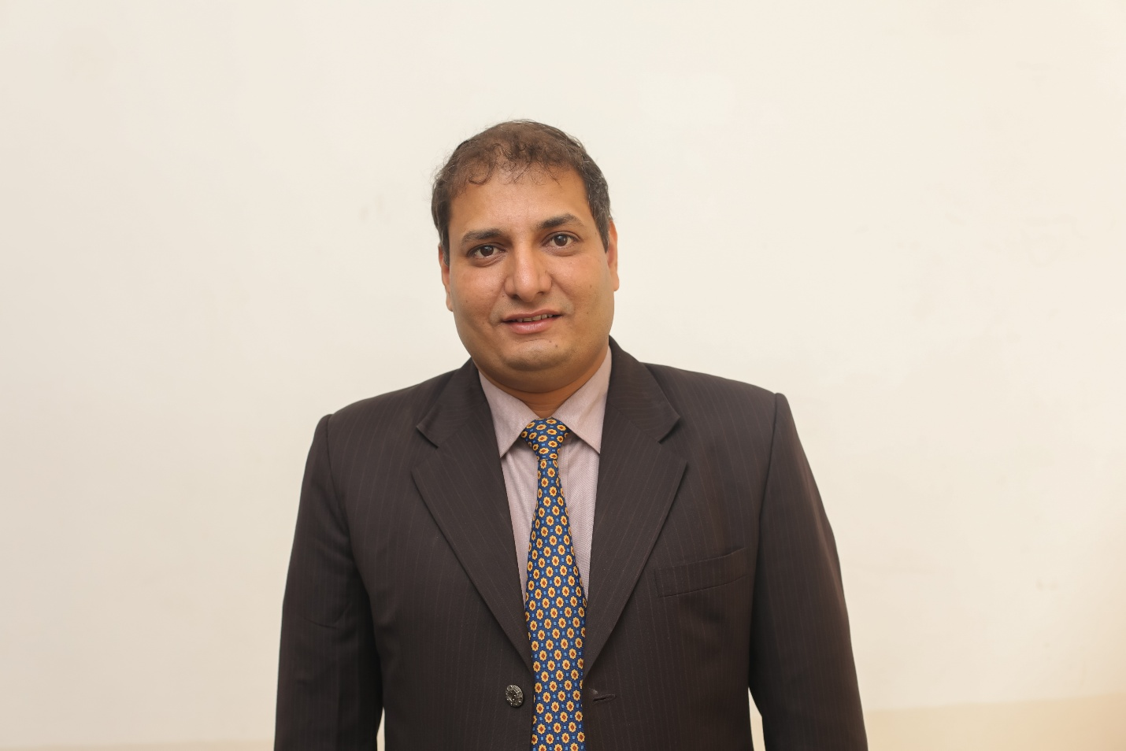

**Over +11 Years** of Professional Excellence in providing Academic Services in different Colleges of Management and Engineering. Completed Doctorate in Management (Ph.D) from DAVV University Indore, MCA from Rajeev Gandhi Technical University Bhopal. Master of Business Administration in Marketing Specialization, from Sikkim Manipal University, B.Sc (Computer Science) from Barkatullah University (Bhopal-M.P.) presently associated with Indore Institute of Law as a Sr. Asst Professor and Batch Coordinator of B.B.A.LL.B.(hons.) course. Associated as Research Supervisor at Pacific University Udaipur. Exam Paper Setter of Graphics Era Hill International University Dehradun & Devi Ahilya University Indore. Observer of Bhoj University Bhopal, International Writer of www. happinessforyou.org ,Associate in Board Member of International Journal of Computer Science and Management Pune, Editor of Maverick International Research Journal of Indore Institute of Law. And recently heading as a Enterprises Resource Planning (Accesoft) Academic Module of Software and heading Technical Coordinator.

**EDUCATION:-**

* Ph.d from Devi Ahilya University Indore in Faculty of Management

**Topic-Role of ICT in the development of Farmer’s Economy and study of ICT-Choupal**.Awarded in year 2014

* Master of Computer Application (MCA) from Rajeev Gandhi Technical University, in 2006 with 71%.
* Master of Business Administration (MBA) from Sikkim Manipal University with marketing specialization in year 2014

**RESEARCH SUPERVISOR:**  **PACIFIC UNIVERSITY UDAIPUR** for Ph.D Research Scholar /Master Course in the Faculty of Management.

Student Name :Ms. Shweta Kapse Research Scholars at Pacific University Udaipur.

**ACADEMIC ACHIEVEMENTS:**

* Attended 10 Days FDP conducted by IPS Academy (IBMR) AICTE sponsored topic Global Meltdown on Indian Economy.
* Attended 2 Weeks Workshop on Entrepreneurship conducted by **CRISP Bhopal** from **27th Jan 2015 to 7th Feb 2015**
* Attended 2 Days workshop on Research Methodology at Christian Eminent College Indore.
* Attended 2 Days National Conferences on Emerging Trends in Computing Trends in Computing And Communication Computer Science at Medicaps Institutes of Techno Management Organized by Medicaps Group of Institutions Indore.
* Attended 2 Days International Conferences on Business Innovations and Entrepreneurship Transforming World Economy **Feb 11, 12 in year 2012**.at PIMR Indore.
* Attended **6th Feb 17 Feb 2013** 10 Days  Faculty Development Programme on High Impact Teaching Skills Through Communication Skills  program organized by Humanities department of Medicaps Institutes of Technology and Management
* Attended **100 days Faculty** Development program by Corporate Trainer Sudarshan lekhak at Medicaps Institutes of technology and Management.
* Attended 10 days Workshop On Research Methodology conducted By IIT Bombay on ICT from **25th July to 4th July 2012** at Medicaps Moodle Center Indore.
* Attended 2 days Workshop on ICT and use of application of **Aakash Tablet** **By IIT Bombay on** **10, 11 Nov 2012** at Medicaps Moodle Center Indore.
* Attended 4 days Training Program of Software Testing conducted by IBM on Functional Testing and TQM.
* Attended IMA (Indore Management Conclave) **7, 8 Nov 2009.**

**NATIONAL ONFERENCE Worked as Organizer:**

* Conducted and participate in National Conference at Medicaps Institute of Technology and Management (MCA) on Future Trends in Information and Communication Technology on date **19, 20 October 2012.**
* Conducted International Social Good Summit **2013 on 24th September** as host of Indian Chapter at Science of Global Peace through Happiness with Mashable (Google).
* Conducted 2 days International Conference at Altius Institute of Universal studies on Changing Management Paradigm in a Dynamic Business Environment **2,3 May 2014**.
* Conducted 1 day Faculty Development Program On Use of ICT tool in Teaching Methodology at Indore Institute of Law .

**INTERNATIONAL WORKSHOP:**

* Conducted 2 days International Workshop @Indore Institute of Law By **BRITISH LEGAL CENTER on 4th,5th May 2015**
* Conducted 1 day workshop on **Intellectual Property Law and Management on 4th June 2015 @Indore Institute of Law by Enhelion Pvt Ltd.**
* **Conducted 1 day International Workshop on Cyber Security & Crime Keynote speaker:Mr Rakshit Tandon Director at All India Mobile Association.Director Crime Branch U.P date17th Dec 2015**

**TEACHING OF VARIOUS SUBJECTS:**

Practise and Principle of Management, Management Information System, Ecommerce-E-BankingProgramming and Laboratory, Software Engineering , Data Ware Housing and Mining, Operating System, Computer Architecture, Computer Graphics Software Testing.Net Framework, Database Management System, Information Technology, Marketing Management,Enterprenurship

Cyber Security.

**INTERNATIONAL RESEARCH AND PUBLICATIONS**

* Attended and presented research Paper in National Conference -Attended One Day National Conference on Managing the Organizations in Post recession World held on 28 Dec 2011.at Acropolis college of Management

**Topic-Role of ICT in urban economic development.**

* Presented research paper in International Conference of Business Innovations and Entrepreneurship: transforming World Economy Feb-11,12 2012 at Prestige Institute of Management and Research

**Topic: Role of ICT in the Higher Education System.**

* Published a Research Paper on Application of

**Topic:** **ICT and Study of Wi-Zone a new era of Wireless Technology and its application**. In Chameli Devi Group of Institutions

* International Journal of Research in Computer Science and Management (ISSN: 2321-8088 Vol.(1),No(1)).on given

**Topic: Future of management and technical education in India and   Recent development of Indian higher education System**

* Published a Research Paper at on Altius journal of Management and Commerce

**Topic: Impact of Information and Communication Technology in the Development of Rural Sector and E-Choupal. ISSN 2348 – 8891**

* **Innovative ICT tools in Quality Education System: A Study of Rural Market Development”** has been accepted by the Editorial Committee for presentation in forthcoming Ninth PIMR International Conference on **“Quality Management Practices for Global Excellence”** January 30-31, 2015.
* **Innovative of ICT tools in education system and learning of ICT Tools in Rural Market development and study of Farmer’s Economy** has been accepted for publication in **International Journal of Research in Computer Science and Management (ISSN: 2321-8088 Vol.(2),No(2))**.
* **An Examination of Transformational Leadership, Gender Role Orientation and Leadership Effectiveness in Public and private sector banks ISSN 2348 – 8891**
* **Innovation of Information and Communication Technology in the Development of IT, Application in Modern Education Education System** Udgam Vigyati Journal of Management and Law @Indore Institute of Law
* **An empirical analysis of the Leadership Effectiveness Relative importance of leadership style in the Industries International Journal of Research in Computer Science and Management.**
* **International Conference on Green, Growth, Globalization and Governance: Opportunities and Challenges 2016**'. We are pleased to inform that your abstract titled "Shri Guru Granth Sahibji Teachings and Principles of Management**"**
* **Talent Acquisition and aspirant satisfaction through Campus Placement has** been accepted for publication in **International Journal of Research in Computer Science and Management [ISSN (P): 2321-8088, ISSN (E):2455-5665 , Vol.(4),No(1)] [Index by (1) DRJI  (2) I2OR [PIF (2015): 1.065] (3) SJIF [(2015): 4.267**.
* Promising inclination of E-Commerce in India: Issues, scenario and Provocat PIMR International Conference.
* **“Innovative of ICT tools in education system. Study of Rural market development, Knowledge and Research ”**to the International Conference on ***"Paradigm Shift in Innovative Business Management"***to be held on 6-7 December, 2014 has been principally selected for publication.

**GUIDED RESEARCH PAPER**

* Future of management and Technical education in India. (Mavericks 2012 a National Level Research Paper Competition”
* Recent development in Indian Higher Education System. **ACADEMIC PROJECT IN MCA AND MBA LEVEL**

Guided more than 200 Students in Major Research Project of MCA, MTech, MPhil(CS) based on Client Server based.in .Net Technology. and ERP .

**CONTACTS-:9098395608** Email:mishrareva@gmail.com