**Mr. Manish Phalke**

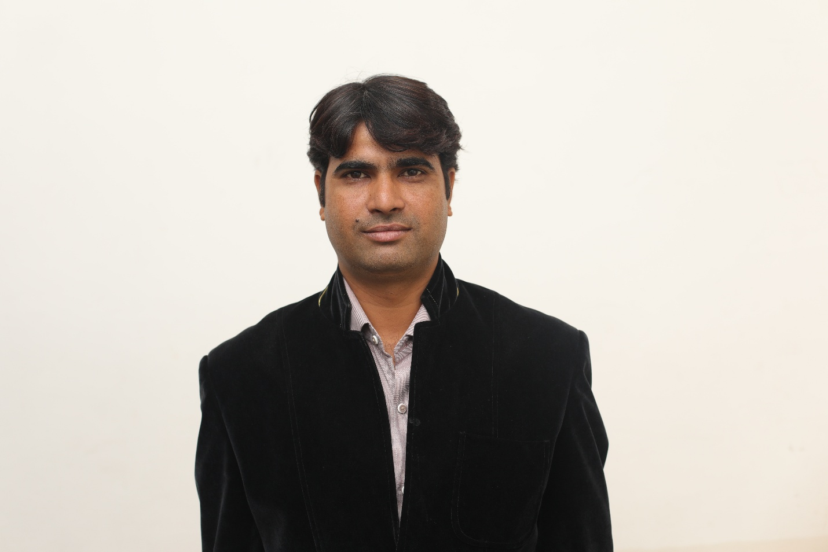

To be a part of organization where the work culture is challenging and environment is competitive, that makes an optimum utilization of my potential and gives me the opportunity to improve my skills and help me in persistent strive for perfection.

**Designation:** Assistant professor

**Qualification:**

* **Ph.D.**-: **Pursuing** **Ph.D.** from DAVV Indore in Management on the topic of “**Impact of Merger on Bank Performance: A comparative study” (Thesis Submitted)**
* **Ph.D. course work**

Cleared Ph.D. Course work from IMS, DAVV Indore

**Master of Philosophy (M.Phil.)** –From Devi Ahilya University, Indore 2007.

Research topic “**Analysis of financial statements of State Bank of Indore”** in the guidance of Dr. Manohar Das Somani (H.O.D. Mhow PG Degree College, Mhow, M.P.)

* **Post Graduation**

**Master of Art (M.A. Economics)** –from Devi Ahilya University, Indore 2009.

* **Post Graduation**

**Master of Commerce (M.Com.)** – From Devi Ahilya University, Indore 2005. (Taxation & Marketing).

* **Graduation**

**Bachelor of Commerce (B.Com.)** – From Devi Ahilya University, Indore. 2003

**Research Work:**

**Paper published in International journal**

* Paper publish in **AIMS International Journal of management on “roll of mutual fund in volatile stock market situation” organized by ICTBM 10, IMT Dubai**
* Paper publish in **AIMS International Journal of management on “Impact of liquidity crunch on Indian Market ” organized by ICTBM 10, IMT Dubai**
* Paper publish in AIMS International Journal of management on “Analysis of motivation Aspect among Sales Professional ” organized by ICTBM 10,IMT Dubai
* Paper publish in AIMS International Journal of management on “Analysis of motivation Aspect among Sales Professional ” organized by ICTBM 10, IMT Dubai
* Paper publish in AIMS International Journal of management on “Challenges of E-Governance in India” organized by ICTBM 10, IMT Dubai
* Paper publish in AIMS International Journal of Management on “Retail Development and Planning police in India” organized by ICTBM 10,IMT Dubai
* Paper publish in AIMS International Journal of Management on “Impact of Liquidity Crunch on Indian Market India” organized by ICTBM 10, IMT Dubai
* Paper publish in AIMS International Journal of Management on “Some Innovative aspects for Promotion of Industrial Relations in Organization ” organized by ICTBM 10,IMT Dubai
* Paper publish in AIMS International Journal of Management on“Impact of Promotional Tools on Consumer Durable Goods” organized by ICTBM 10,IMT Dubai

**Paper publish National journal**

* Paper publish in journal of Organization Excellence on **“Ratio Analysis : Enlighten of Dark Tunnel of Risk”** organized by Prestige Institute Of Management, Dewas
* Paper publish in journal of Organization Excellence on **“Roll Of Environmental Marketing”** In The Country organized by Prestige Institute Of Management, Dewas

**Additional Courses Taken:**

* Attending Faculty Development Program (FDP) on Research Methods and E-Views in Dhaka, Bangladesh
* Attended one week short-term training program Organized by **Institute of Management Studies (IMS) Ghaziabad** (sponsored by Indian Society for Technical Education ISTE, AICTE) **on Impact "Issues, Trends and challenges in financials market”**

**Email-id -:** [manish.phalke@gmail.com](mailto:manish.phalke@gmail.com), **Contact-**:09827048285