Dr. Kavita Dive
Asst.Professor Indore Institute of Law
E mail : kdkavitadive@gmail.com

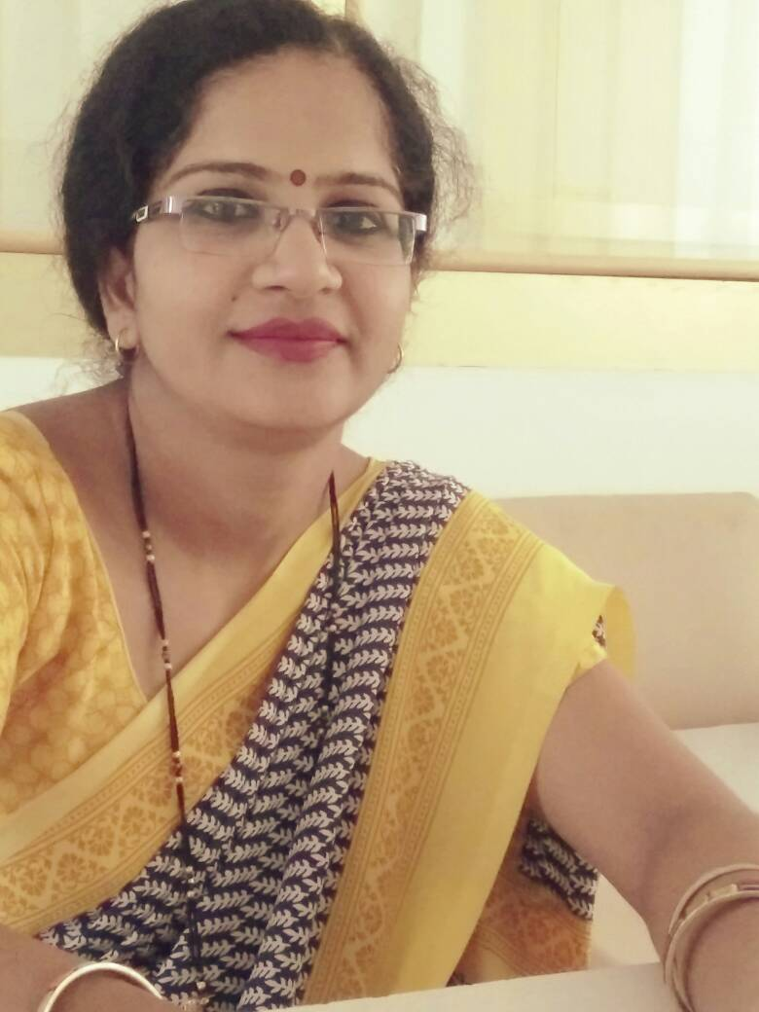

About the faculty
I have Joined Indore Institute of Law August 2014. I have M.Phil. Programme in 2002-03 from DAVV and I a Ph.D. in commerce awarded in 2016. I specialise in financial accounting, corporate accounting, economics, banking and cost accounting. I have a teaching experience of 13th year. I have been activity engaged with teaching the under-graduate and post-graduate courses in specialised area. I have participated in various national conferences while my research papers have been published in national and international Journal.
I am a focused and hardworking professional who ensures creativity, and passion in work .I am also a quick learner with excellent computer, Internet and other soft skills.

Objective:
A positive, self motivated and team oriented professional seeking a challenging opportunity to utilize my technical, interpersonal, and organizational skills with in a reputable organization.

Educational Qualification

Qualification | University/Board | Specialisation | Passing of year | Percentage
Ph.D. | DAVV | Commerce | Awarded  2016 | -
M.Phil. | DAVV | Commerce | 2002-13 | 81%
M.com | DAVV | Commerce | 2002 | 65%
B.com | DAVV | Commerce | 2000 | 65%
M.A. | DAVV | Economics | 2011 | 57%
HSC | MP. Board | Commerce | 1997 | 60%

Other Courses
- Computer Courses from Krishana Training Institute Education in 2005, WINDOWS, MS OFFICE 2000, Internet, Tally, Visual Basics.

Work Experience

College Name | Post | Work Experience
Indore Institute Of Law | Assistant Professor | From July 2014 till
Radiant institute Of Management and Science | Head & Asst. Professor | July 2009 to July 2013  (Selected Under College Code 28)
School of commerce | Visiting Faculty | Sep 2011 to Dec 2011
Kothari College | Assistant Professor | July 2005 to June 2008
Satya Sai Bal Vinay Mandir, Indore | Lecturer | July 2000 to April 2003

Academic Achievements:
International Workshops

- Attended International Workshop on Intellectual Property: Law & Management conducted by Enhelion Knowledge Ventures Pvt. Ltd. On 4th June 2015.
- Attended International Workshop on Legal Writing & Contract Drafting Training on 4th & 5th May 2015 conducted by British Legal Centre.

National Workshop

Attempt work shop on “cyber-crime” organised by Indore Institute of Law on 17th December 2015.

National Conferences and Seminar

- Paper presented in national seminar on the topic ‘Resent trend in commerce education’ Analysis view organized by Idyllic Institute of Management on 23rd and 24th November 2015.

- Paper presented in national seminar on the topic ‘Need to Increases the Important of Commerce Stream – Analysis View’, Organized by Guajarati College Indore Sponsored by UGC Bhopal 11 & 12 February 2012

- Paper presented in national seminar on the topic ‘Developing Approaches in education quality – A study’ Organized by Shri Vaishnav College of commerce Indore sponsored by UGC Bhopal 8 & 9 September 2011.

- Paper presented in national seminar on the topic ‘Cross Culture Communication In India - An Analysis’, Organized by Christian Eminent College, Indore sponsored by UGC Bhopal 13March 2010.

Research Paper Published in International Research Journals

- Research paper published in International referred research journal 2012 January Vol. III Issue 36e –Impact of Customer’s satisfaction on Retail- Banking.
- Research paper published in SAARJ Journal on Banking & Insurance ISSN: 2319-1422 Vol.4 Issue 4- July-Sep2015 Topic ‘Factors Influencing the Level of Customer Satisfaction of Retail Banking In State Banking of India with special Reference to Indore City’
- Research paper published in International referred research journal 2012 January Vol. III Issue 28-‘Consumer Complaint against Consumer Protection Act an Analysis’.

Research Paper Published in National Research Journals

- Research Paper published in National referred research journal Udgam Vigyati 2015 Vol. I, ISSN No.2455-2488 E - Commerce Trend “Online shopping”

- Research paper published in research Link Vol. X (11)Jan 2012 Indore - A study of saving comparison in Cooperative Bank & commercial Bank

- Research paper published in research Link Vol. X (12)Feb. 2012 Indore - Market Demand Analysis in Cellular Company

Articles published:

- “Changing Dimensions of Black money in India” Published in Nyay Disha November 2016.
- “Natural Resources and economic Development in India” Published in Nyay Disha December 2016.
- “Structure of Indian Industry: Public and Private Sector Enterprises” Published in Nyay Disha January 2017.

Publication under Process:
- Research paper forwarded to “MAVERIKS” An International Journal of Inter Disciplinary Studies entitled “Consumer Protection Act”
- Research paper forwarded to “Udgam Vigyati”An national Journal of inter disciplinary studies “Five Year Economic Planning in India –Critical View”
- Research paper forwarded to “Udgam Vigyati”An national Journal of inter disciplinary studies National Income & Its Impact on the Indian Economy
- Research paper forwarded to “”Udgam Vigyati An national Journal of inter disciplinary studies Demonetisation Effects in India
- Research paper forwarded to “Nyay Disha”An national Journal of inter disciplinary studies Tolerance- Modern way of Living
- Research paper forwarded to “Udgam Vigyati”An national Journal of inter disciplinary studies Effects of fiscal policy
Various Events Contribute as an Event Coordinator:

- Seminar, Workshop & Conference.
- Attended & Contribute the National Symposium on “Whither Indian judiciary” on 21st June, 2016.
- Attended & Contributed International seminar on “Cyber Law & Security” on 17th Dec, 2015 at Indore Institute of Law. The key note speaker was Mr. Rakshit Tandon, Director- ASR Info Security Solution Ptv. Ltd.
- Attended & Contributed International workshop on “Intellectual Property Law & Management” on 4th June, 2015 at Indore Institute of Law. The key note speaker was Mr. Rodney D. Ryder.
- Attended & Contributed Organised International Workshop in association with British Legal Centre on “Contract Drafting & Legal Document Writing” on 4th 5th May, 2015 at Indore Institute of Law, Indore. The Key speaker was Mr. Malcom Dowden, Director of LAW Programmes, Law 2020, Partner, Indian Legal Centre.

Academic Competitions & Events Coordinate
- “Graduation Ceremony” of Batch 2011-16 on 3rd Aug, 2016 at Indore Institute of Law .The Chief Guest of the day was Mr. T. Krishnan, Director, Indian Institute of Management, Indore.
- II Alumni Meet of Indore Institute of Law and declared the Alumni Board of IIL on 26th June, 2016 at Basket Ball Complex in Concert of Aditi Singh Sharma.
- Model United Nations Competition on 16th May, 2016 at Indore Institute of Law.
- Moot Court Competition on 14th & 21st May, 2016 at Indore Institute of Law.
- The national Law Fest “Lex Bonanza” on 31st Oct & 1st Nov, 2015. It comprises of 7 events National Moot Court Competition, National Parliamentary Debate Competition, National Law Quiz Competition, National Judgment Writing Competition, and National Debate & Extempore Competition at Indore Institute of Law.
- Moot Court Competition on 10th Oct, 2015 at Indore Institute of Law.
- I- Alumni Meet of Indore Institute of Law on 19th Sept, 2015.
- “Graduation Ceremony” of Batch 2010-15 on 19th Sept, 2015 at Indore Institute of Law .The Chief Guest of the day was Mr. R.D. Musalgaonkar, Registrar DAVV, Indore.
- Parliamentary Debate Competition on 29th May , 2015 at Indore Institute of Law.
- Attended & Contribute FACULTY DEVELOPMENT PROGRAME on 4th April, 2015. The key note speaker was Prof. Dr. Nisha Dubey, Former Vice Chancellor, Barktullah University, Bhopal & Prof. (Dr.) Mukund Sarda, Dean, Faculty of LAW, Pune.
- 12th Shri Gendalal Ji Bam Memorial Debate Competition on 26th Jan, 2015 at Indore Institute of Law.
- The National Law Fest “Lex Bonanza” on 27th & 28th Sept, 2014 comprising of 7 National Events at Indore Institute of Law, The Chief Guest was Hon’ble Justice Altamas Kabir, Former, Chief Justice of India.
- Judgment writing Competition on 12th July, 2014 at Indore Institute of Law.
- Moot Court Competition on 30th July, 2014 at Indore Institute of Law.
- Faculty Development program on 19th April, 2014 on “Research Methodology”. The Key Note Speaker Dr. D.N. Sansanwal, Former Head & Dean, Department of Education, DAVV.

Cultural Events Contribution
- Traditional Day “Dandiya Raas” on 7th Oct, 2016 at Indore Institute of Law.
- Induction “Exordium” at Indore Institute of Law in 2014, 2015 & 2016 consecutively. Induction is a welcome party to the fresher which comprises of Talent Hunt, Fashion Show & Sports Day.
- Republic Day celebration at Indore Institute of Law in 2014, 2015 & 2016, 2017 consecutively.

Sports Events Contributions
- “Leg Cricket” on 23rd July, 2016 at Indore Institute of Law.
- Intra College Volley Ball Competition on 13th Oct, 2015 at Indore Institute of Law.

Event Contributions for Practical Exposure
- An Educational Visit to Lok Adalat on 12th Dec, 2015 at District court, Indore.

Activities Contributions for Social Awareness & Communities Work
- “Animal Moot Court” on World Environment Day on 5th June, 2016 for saving wild life & environment created world record of maximum people (175) in animal attire in Golden Book of World Record, USA.
- A visit to old age home on 28th May, 2016 of 200 students & distributed hampers of daily necessities and conducted a seminar on Respect of Senior Citizens.
- National Seminar on “Secrets of Sound Mind & Sound Body by Alternate Means” on 4th May 2016 at IIL.
- Coordinated NSS Camp of 7 Days of 100 students in Tillore Village from 29th Feb to 06 Mar, 2016
- A theatre Play” FANDI” on Euthanasia on Human Rights Day 10th Dec, 2015
- Conducted student’s society election 2016, 2015 & 2014 consecutively for encouraging students Participation in society by different student society like Legal Aid, Alumni Etc.
Research Projects

- “Co-operative Bank & Societies in Short Saving”(With Special Reference Shub Laxmi Cooperative Banks Indore) 2002-03Under Guidance’s in Dr. Ramesh Mangle.
- Packing Product Quality in Manufacturing M.phil 2002-03under Guidance in Dr. Ramesh Mangle
- “A Study of Customer Satisfaction in Retail Banking” (With Special Reference State Bank of India 2011-16 Under Guidance in DR. M.D. Somani.

Monograph Publication

- Monograph Published under Nokada Publication “Social work Research and Statistics”

Specialization Of subjects

Accountancy, Company Accounts, Cost Accounts, Statistics, Economics, Management

Job Responsibility

- Appointed as Asst. Prof. Indore Institute of Law since August 2014.
- Impact Lectures as Assistant Professor.
- Appointed as the Event Co-coordinator regulation.
- Conducted university examination and acted as senior exam superintended & superintend at various occasions.
- Evaluates the university answer sheet of DAVV & the registration no. is 5014
- Appointed as Head of Election Commission Society.

Administrative Work

- Teacher Representative in college Governing Body.
- Do all work as in charge of commerce
- Co-ordinator of Semester cell.
- Handling some of the admin. Activities.
- Handle society work ( Head of Election commission)

Skills

Excellent Communication skill, Good Team player, Good Organizing & Coordinating Skill, MS - Office, Tally, Internet, Administrative Work Experience Society Management skills, Event Management

Personal Details

Name: Dr. Kavita Dive
Husband Name: Mr. Bhushan Dive
Marital status: Married
Date of Birth: 20/Aug/1979
Hobbies: Listening music, Reading
Gender: Female
Nationality: Indian
Language: Hindi, English, Marathi
Address: Shri Krishana Avenue Flat No. 404, Shanti
Heights Block -D, Limbodi, Khandwa Road. M.P
Contact: 9993586364
Email Id.: kdkavitadive@gmail.com.

Reference:
- Dr. M.D. Somani
Prof. Deptt. Of Commerce
Mata Jija Bai Girls College, Indore
- Dr. Ramesh Mangle
Retd. Principal Deptt. Of Commerce
Vaishnav commerce College, Indore

Declaration

I hereby declare that all the above information are true and correct to best of my knowledge.

Date:
Place: Prof. Dr. Kavita Dive

