**Indore Institute of Law**

(Affiliated to D.A.V.V & B.C.I)

**Name of Faculty: Mrs. Bharti Meghani Mishra**

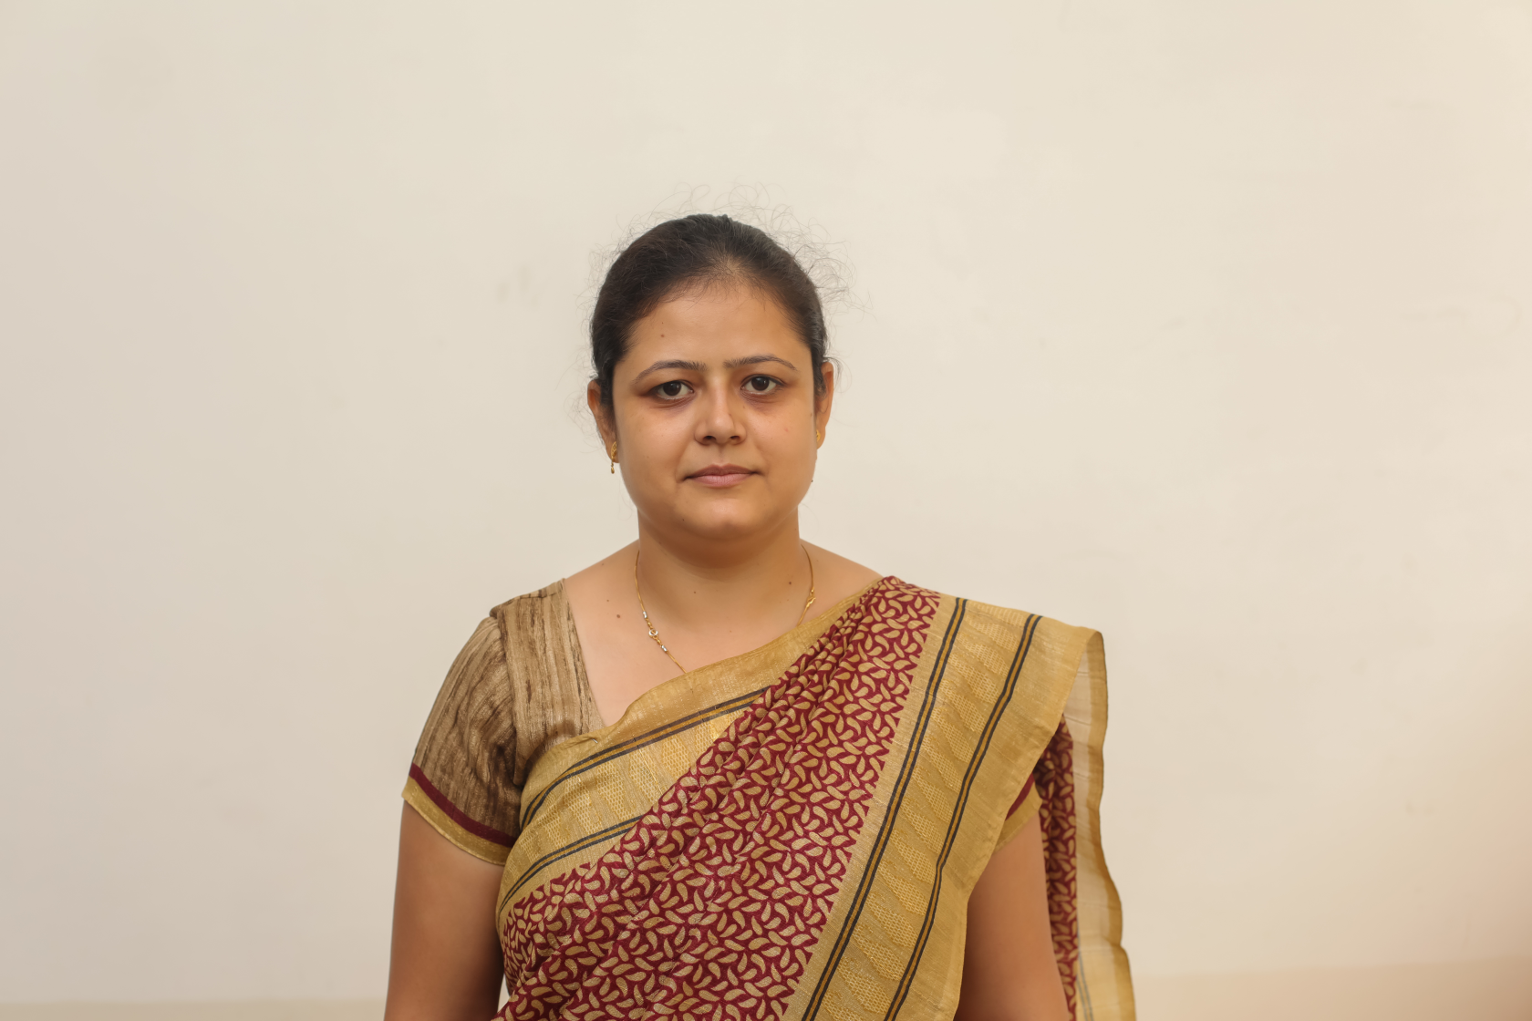

**ABOUT THE FACULTY**

She joined Indore Institute of Law in the year 2017 on 16th May. She is Alumni of Indian Institute of Management- Indore (IIM-Indore). She has industry experience of 2 years and academic experience of 5 years. She is pursuing Phd (submitted) from MLSU, Udaipur. She has one international publication and 4 national publications in UGC approved journals. She has presented research paper in IIM-Indore Conference. She has attended Faculty Development Program of IIM-Indore. She has also worked with IIM-Indore. She is a certified trainer of ‘Entrepreneurship Development’ and has attended training program of SMVDU, Jammu. She is also proficient in taking Personality Development sessions for students.

**DESIGNATION AND QUALIFICATIONS**

Working as Assistant Professor in IIL since 16th May’2017.

Ph.D (submitted).

M.B.A (Business Economics) in 2008 from IPS Academy, Indore, M.B.A (Human Resource) in 2012 from IMS, DAVV, Indore.