**Indore Institute of Law**

(Affiliated to D.A.V.V & B.C.I)

**About the Faculty: Mr. Ashutosh Shrivastav**

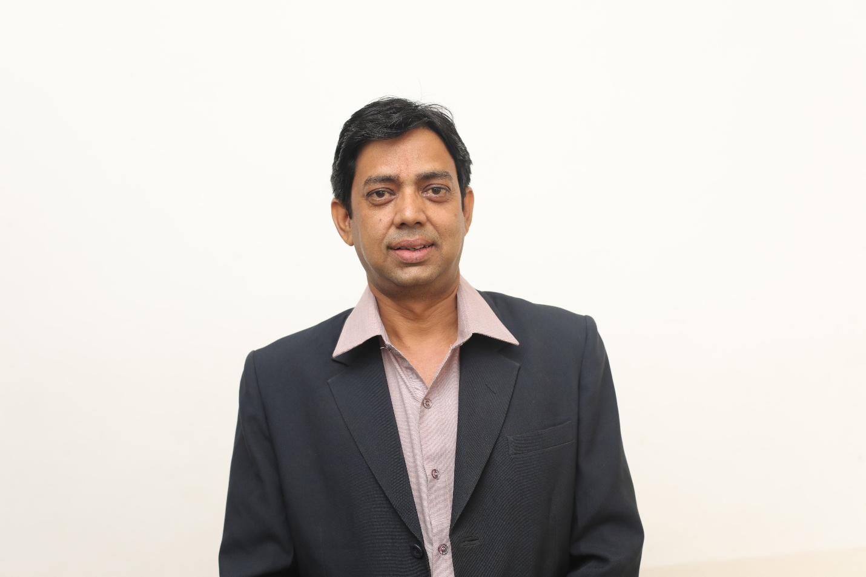

**Mr Ashutosh Shrivastav** is working as Assistant Professor in Indore Institute of Law, Indore M.P. India. He has 09 years of rich experiences in the field of academics and also having the experience as an Advocate. Previously, he has worked as Assistant Professor in Shri Vaishnav Institute of law, Indore. Before that he has worked **as** Founder Lecturer of Human Rights Two years Degree programme in Department of Political Science, Vikram University Ujjain (M.P.) for more than one year. He has worked as Centre Head of D.A.V.V. Examination of B.A.LL.B. and LL.B. also. He is Working as the Head of the Legal Aid Society of the collage He has also attended various Seminar & Conferences at National Levels.

**Designation**

* Mr **Ashutosh Shrivastav** is working as Assistant Professor in Indore Institute of Law,Indore (M.P.)

**Qualification**

# 

# .

1. L.L.M. Degreewith specialization in i. Law of Crimes and Human Rights From University of Mumbai . Mumbai.
2. LL.B. From DAVV, Indore

**Article Published**

“The Consumer Protection and welfare in India” Published in Naya Disha.

**Seminar, Workshop & Conference.**

* Attended the National Symposium on “Whither Indian judiciary” on 21st June, 2016.
* Attended International seminar on “Cyber Law & Security” on 17th Dec, 2015 at Indore Institute of Law. The key note speaker was Mr. Rakshit Tandon, Director- ASR Info Security Solution Ptv. Ltd.
* Attended International workshop on “Intellectual Property Law & Management” on 4th June, 2015 at Indore Institute of Law. The key note speaker was Mr. Rodney D. Ryder.
* Attended International Workshop in association with British Legal Centre on “Contract Drafting & Legal Document Writing” on 4th 5th May, 2015 at Indore Institute of Law, Indore. The Key speaker was Mr. Malcom Dowden, Director of LAW Programmes, Law 2020, Partner, Indian Legal Centre.
* Attended an Interactive session by Ms. N. Saraswathy Devi, Malaysian Solicitor on 14th July, 2014 at Indore Institute of Law.
* Attended two days National Seminar on “challenges of Human Rights” organized by Human Rights Department, DAVV.Indore. on 12 &13 sept 2013
* Attended the National Seminar on “Future of International & Domestic Arbitration in India” on 21st Sept, 2013 at Indore Institute of Law. The Key note speaker was Hon’ble Justice A.K. Sikri, judge, Supreme Court of India.
* Attended the National Seminar on “Criminal Trial & Investigation system in India” on 17th Aug, 2013 at Indore Institute of Law. The key note speaker was Hon’ble Justice M.L. Tahaliyani, Judge, Bombay, High Court.
* Attended the National Seminar on “Constitution & Courts” on 21st Dec, 2012 at Indore Institute of Law. The key note speaker was Padma Bhushan P.P.Roa, Sr. Advocate, Supreme Court of India.
* Attended National Conference on “Lawyers for Social Justice” in association with National Alliance of people’s movement on 25th & 26th Aug, 2012 at Indore Institute of Law. The key note speaker were Hon’ble Justice A.K. Ganguly , Former Judge, Supreme Court of India & Meda Patekar ji, Social Activist.
* Attendance the National Seminar on “The Evolving Laws Pertaining to Criminal Justice & Human Rights” on 28th July, 2012 at Indore Institute of Law note Speaker was note speaker was Hon’ble Justice Gyan Sudha Mishra, Judge, Supreme Court of India & Hon’ble Justice Shubhada Waghmari, Judge, M.P. High Court.
* Attended the National Seminar on “Democracy & Corruption” on 21st July, 2012 at Indore Institute of Law the key note speaker was Hon’ble Justice Santosh N. Hegde, Former Judge , Supreme Court of India .
* Attended one day training program on **“Patent Filing System-India US & PCT Mode**” organized by Confederation of Indian Industry (CII)- Intellectual Property Facilitation CENTER (IPFC) Indore.
* Attended the National Seminar on “Limited Liability partnership Act & it’s effects” on 26th May, 2012. The key note speaker was Padma Shri P.H. Parikh, Senior Advocate Supreme Court of India & President Supreme Court Bar Association.
* Attended the National Seminar on “Money Laundering Regulation- A ted to curb corruption in India” on 14th April, 2012 at Indore Institute of Law the key note speaker was Adv. Ram Jethmalani Member of Parliament & Sr. Adv. Supreme Court of India.
* Attended the National Seminar on “The Role of lawyers in advancing civil rights protection” on 31st March, 2012 at Indore Institute of Law. The key note speakers were Hon’ble Justice V.S. Kokje, Former Governor, Himachal Pradesh, Hon’ble Justice P.D. Mulley, Judge, M.P. High Court & Adv. Geeta Lothra, Sr. Adv. Supreme Court of India.
* Attended the National Seminar on “Police & Populace” on 29th July, 2011 at Indore Institute of Law. The Chief Guest was Mr. Vineet Kapur, Asst. Inspector General of Police.

**CONTACTS-:** 98826388162.

E-Mail-: ashutoshniya@gmail.com