**INDORE INSTITUTE OF LAW**

(AFFILIATED TO D.A.V.V & B.C.I)

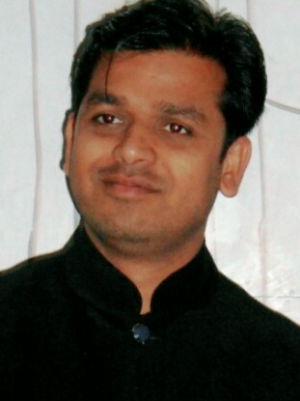

**ABOUT THE FACAULTY**

A challenging and varied teaching role that will utilize my knowledge and professional experience, offering opportunities for personal and professional growth. He has vast years of an corporate experience in Netlink Software Pvt. Ltd., As a Operation Manager (SECC) Bhopal, Dec 2011 to Aug 2014. HSBC Banking Services, As a Assistant Sales Manager Indore, Nov 2007 to March 2010. Bharti Airtel Ltd., as a Team Leader – Guna Jan 2004 to May 2006.

**DESIGNATION AND QUALIFICATION-:**

Assistant professor-: English

**M.B.A.(international bussiness), M.A.(English Literature), B.Com ( Taxation).**

***COURSE TAKEN-:*** *English*

Contacts-:

Mobile: 7987561329, Email: **aashishkumarsoni17@gmail**​**.com**