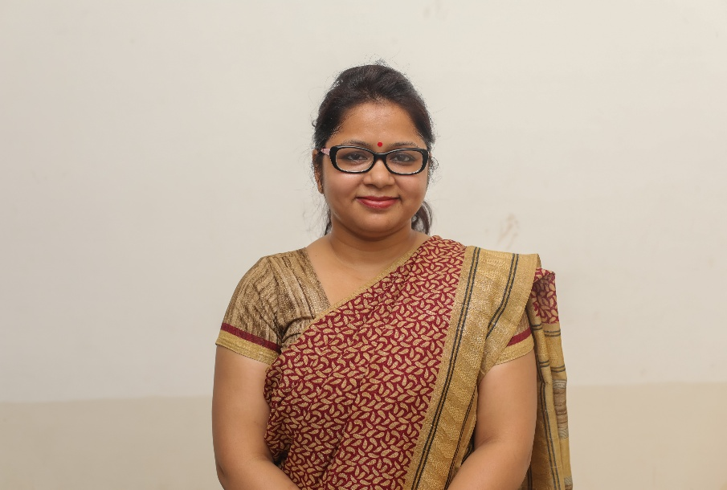

**Amrita Singh**

Amrita Singh is working as Assistant Professor at Indore Institute of Law, Indore M.P. India. She has 1 year of experience in the field of academics with 1 year of experience in corporate and also having the experience as an Advocate. Previously, she has worked as Education Counselor in Tajeduglobe Ltd, Varanasi. Before that she has worked with RDSJ Law College, Lucknow for one year as a Lecturer. Her areas of interest are Administrative Law & Tort, etc. She is a graduate in Political Science (Hons.). She is also a law graduate and Postgraduate & registered Advocate. She has presented & published various research papers in National / International Seminars & Conferences.

**Designation:** Assistant Professor

**Qualification:**

1. LL.M. in Administrative Law from Mahatma Gandhi Kashi Vidyapeeth, Varanasi, Uttar Pradesh.
2. LL.B. from Banaras Hindu University, Varanasi, Uttar Pradesh.
3. B.A. from Banaras Hindu University, Varanasi, Uttar Pradesh.

**Publications (4)**

* “Honor-Based Violence against Women: A Legal Prospective” April, 2014.(ISSN 2231-413X)
* “Fundamental Rights of Indian Citizens” October, 2014 (ISSN 2348-4675).
* “Female feticide” November, 2014 (ISSN 2348-4675)
* “Rule of Law” 2017 (ISSN 2277-8454)

**National & International Seminars (11)**

* Presented a paper on *“Place of Women in Indian Culture”* in National Seminar on “Challenges and Prospects of Indian culture in present times”, in the Department of Sociology. Banaras Hindu University on 26th -27th March, 2014.
* Presented a paper on *“Democracy, Governance and Human Rights”* in National Seminar on “Globalization, Law & Protection of Human Rights: Issues & Challenges”, in the Department of Human Rights, School of Legal studies, BBAU, Lucknow on 13-14 October, 2014.
* Presented a paper on *“Judicial Appointments and* *Judicial Independence”* in National Seminar on “Appointment and Accountability of Judges in India” by Department of law, School for Legal Studies, BBAU, Lucknow on 13th -14th November, 2014.
* Presented a paper on “*Challenges & Relevance of Police Force in Modern India*” in National Seminar on “Challenges & Relevance of Police Force in Modern India” by Department of Law, Mahatma Gandhi Kashi Vidyapith, Varanasi on 20th -21st February, 2016.
* Presented a paper on “*Contempt of Court: A Challenge to the Rule of Law”* in UGC sponsored National Seminar on “Changing Dimensions of Morality & Ethics in Legal Profession: Challenges & Prospects” by Department of Law, Hidaytulllah National Law University, Naya Raipur, Chhattisgarh on 19th -20th March, 2016.
* Presented a Paper on *“Efficacy and Compliance of Indian Environmental Law & Policies”* in UGC sponsored National Seminar on “Strengths & Weaknesses of Indian Environmental Laws: A Critical Analysis” by Department of Law, Hidaytullah National Law University, Naya Raipur, Chhattisgarh on 22nd October, 2016.
* Presented a Paper on *“Global Terrorism: A Conflict of Fundamental Ideologies”* in International Seminar on “Global Terrorism” by Geeta Institute of Law (Affiliated to Kurukshetra University), Samalkha, Panipat, Haryana on 12th – 13th November, 2016.
* Presented a Paper on “*Smart Digital Governance*” in IAMD sponsored National Seminar on “Smart City Vs. Smart Village: A path towards Startup India- Opportunities, Issues & Challenges” by Faculty of Commerce & Management Studies, Mahatma Gandhi Kashi Vidyapith, Varanasi on 10th – 11th January, 2017.
* Presented a Paper on *“Sexual Harassment & Constitutional Law of India”* in UGC sponsored National Seminar on “Sexual Harassment: Problems & Challenges” by Department of Law, Mahatma Gandhi Kashi Vidyapith, Varanasi on 5th February, 2017.
* Presented a paper on *“Cyber Obscenity & Victimization of Women”* in International Seminar on “Cyberspace: Instrument of Global Communication or Advanced Ammunition” by Geeta Institute of Law (Affiliated to Kurukshetra University), Samalkha, Panipat, Haryana on 12th November’2017.
* Presented a paper on *“The Role of Educators in Preventing & Responding to Child Sexual Abuse in Institutions”* in National Conference on “The Role of Educators in Preventing & Responding to Child Sexual Abuse in Institutions” by Presidency University, Bangalore, Karnataka on 27th November’2017.

**WORKSHOPS (1)**

* Attended an International Workshop on “How to be a legal negotiator” in association with the Negotiation Academy, Vienna, Austria by Indore Institute of Law (Affiliated to DAVV), Indore, M.P. on 15th November’2017.

#### Courses Taken

* Administrative law
* Jurisprudence
* Indian Penal Code
* Gender Justice

Email-id[**amritalaw8@gmail.com**](mailto:amritalaw8@gmail.com)*Contact***: +**919451236420