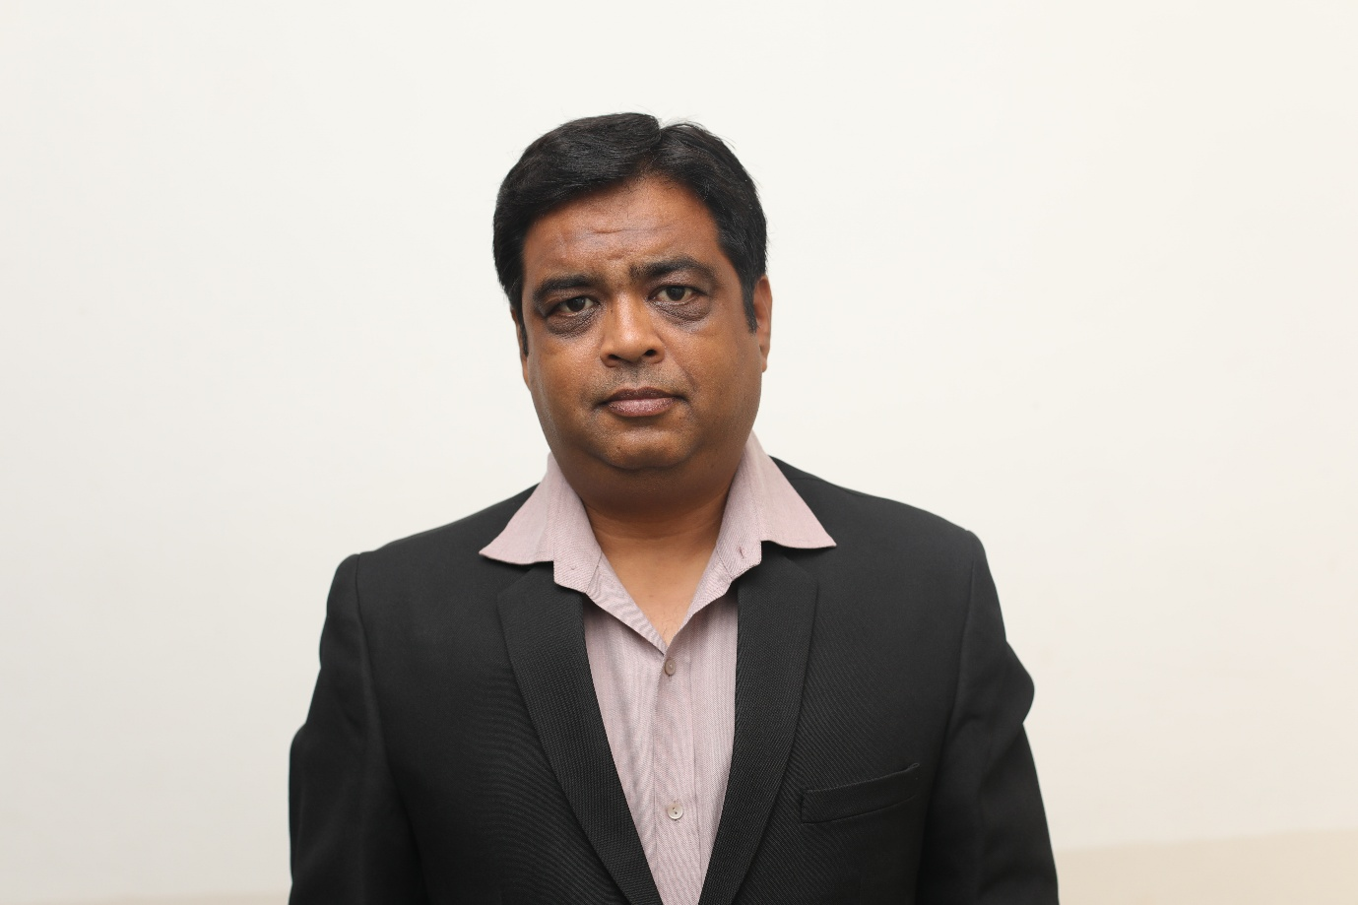

**Mr. Ambarish Bapat**

Mr. Ambarish Bapat is working as an Assistant Professor at Indore Institute of Law, Indore M.P. India. He has 14 years of teaching experience in the field of academics. Mr. A. Bapat previously worked at Sanghvi Institute of Management and Science, Rau, Indore, as an Assistant Professor and was head of department for Under Graduate Courses. He also worked as an assistant professor at Indore Christian College, Indore for Computers.

He was visit faculty at Shri Vaishnav Institute of Management (SVIM), Prestige Institute of Management and Research (PIMR), School of Journalism and Mass Communication (SJMS), DAVV and Acropolis Institute of Technology and Research (AITR).

**Designation:** Assistant Professor

**Qualification:**

1. **MBE (Systems)** – **Master of Business Economics** (**Systems**) from **School of Economics, DAVV**, Indore.
2. **B. Sc. (Computer) – Bachelor of Science (Computer)** from P. M. B. Gujrati Science College, DAVV, Indore.

**Research Work:**

* Published a research paper titled “**Women Empowerment and Crime against Women in Central India**”, in **aWEshakar, a Peer Reviewed Research Journal**, Vol. XXI Issue II, September 2016, pp. 25 – 38, **ISSN 0974 – 1119**.
* Published a research paper titled “**Comparison of Various Saving Schemes in Indian Household Sector**”, in **Essence, Journal of Management and Research**, Vol. 2, Issue 2, December 2013,pp. 23-34, **ISSN 2319-5487**.
* Published and presented research paper titled “**New Trends in Banking: A Study with Special Reference to Changes in Banking Industry**”, in a research journal published in a conference on “**Science, Technology & Society**”, held at Indore Christian College, Indore in March 2011.
* Published a research paper titled “**Employment in Public and Private Sector in India: Futuristic approach and comparison**”, in a research journal published in Sanghvi International Conference on Management in February 2011.
* Published a research paper “**Impact of Information Technology on Rural Economy – With Special reference to E – Choupal**” in **Journal of Madhya Pradesh Economic Association, Volume XIX, No. 1**, November 2009.

**Conferences Attended:**

* Attended a one day seminar on “**Development Prospect of Madhya Pradesh**” held at **School of Economics, DAVV**, September 15, 2012.
* Attended “**NECTOR: Case Writing Workshop”**, held at **Sanghvi Institute of Management and Science**, Indore, July 28 - 30, 2011.
* Attended a one day “**Research Methodology Workshop**” held at S**anghvi Institute of Management and Science**, Indore, June 18, 2011.
* Attended an **International Conference** on “**Science Technology and Society**”, at **Indore Christian College**, Indore, on March 12 – 13, 2011.
* Attended “**SICOM”,** an **International Conference** at **Sanghvi Institute of Management and Science** on “**Sustaining Competitive Advantage through Value Creation**”, February 18 – 19, 2011.

**Courses Taught:**

* Economics – (Micro & Macro)
* Business Statistics
* Research Methodology
* Computer Applications
* Business Environment
* Managerial Economics
* Management Information System
* Introduction to Indian Economy

**Email-id-:** [**ambar_bapat@yahoo.com**](mailto:ambar_bapat@yahoo.com)**, Contact-:9826289882**